

International Information Technology University

Международный университет информационных технологий

**Laboratory work – 1**

for discipline

**Development of Web Applications based on Framework (ISD-3)**

Done by Medina Temirtekova

Khamida Amantur

ITIS - 1903

2022

**Medical System**

1. **Introduction**

Aim - create an application that contains all the functions that a person may need when tracking his physiological state, searching for information, communicating with doctors and other medical issues.

1. **Description**

Medical system is designed to optimize the work in medical institutions and save time for organizations and users. It is aimed at reducing the number of people waiting in line for medical care in the country. In our country do the many surgeries are difficult or do not have the necessary equipment. In such cases, the patients are not able to receive timely care, and it can be life threatening. It takes from a few days to a week to send abroad. So this system will help faster find the medical centers which patient need. With the help of many functions, the patient will have every opportunity to monitor his health, search for all the information he needs related to medications, diseases, and even consult doctors on certain issues.

1. **Technical requirements**

Enter

Log in

Enter without authorization

Sign up

Emergency call

First aid

Health tracking

Account

Medication plan

Reminder

Contact to doctor

Documents

Symptoms

Pills

Hospitals

Search

Notifications

News

Home page

Documentation

1. **Comparative analysis**

  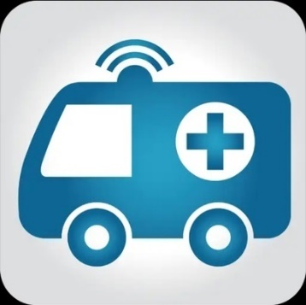

**Damumed Doctor’s guide Urgent care**

|  |  |  |  |
| --- | --- | --- | --- |
| **Damumed** | **Doctor’s guide** | **Urgent care** | **Medical System** |
| Appointment; Find a specialist; Find medicines; Call a doctor; Find a service | Medical calculators; Laboratory diagnostics; Disease Treatment Standards;  Classification of diseases | Doctor call  Urgent care  Emergency numbers  First aid instruction | Registration of hospitals and patients; Search for hospitals (from your region or other countries), medications, diseases; News and notifications; Appointments and documents; First aid; Emergency call; Consultation; Medication plan; Patient’s health tracking |

1. **User roles**

User - is the main consumer of the system. He can see news concerning medicine. Look for medicines, hospitals, get advice from doctors. Also, if necessary, you can add the ability to monitor your health: create reminders to take medication on time, the ability to get first aid, and so on.

Doctor – is also a consumer, while having more functions. There is a possibility of all functions available to the client. A base could also be set up for doctors where they can consult with their colleagues to gain experience and qualifications.

Hospitals - will get a requests from patients/users to online register and to other medical services

1. **Use-case diagram of medical website**

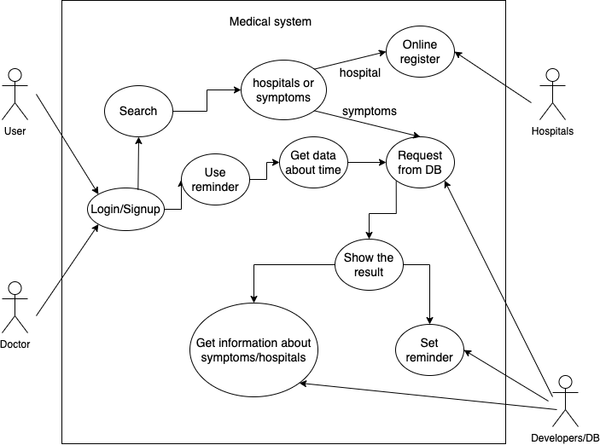

1. **Conclusion**

In conclusion, we want to add that the system is designed for people to facilitate many medical functions. From making an appointment, to finding the right information and consultation. Considering that the treatment of a disease can lead to many problems, from finding qualified doctors to searching among foreign medical institutions, the system has many advantages. The creation of a unified system of hospitals will help patients save time, generate the necessary documents, automate the process of hospital work, and much more, which is very important at the present time.